Study of Linux operating system

horizontal line

# Operating System

An Operating System (OS) is a collection of software that manages computer hardware resources and provides common services for computer programs. It provides a user with an interface that makes any application attractive and user-friendly.

# List of OS

* **MS-DOS:**

MS-DOS which is short for Microsoft Disk Operating System is a non-graphical command line operating system developed for IBM compatible computers with x86 microprocessor. The operating system used a command line interface for the user to input commands to navigate, open and manipulate files on their computer.

**Features:**

It is a single user operating system meaning only one user can operate at a time.

It is a light weight operating system allowing users to have direct access to the BIOS and its underlying hardware.

Loads data and programs from external sources and bring them into the internal memory so they can be used on the computer.



* **Windows Operating System:**

Windows is an operating system designed by Microsoft to be used on a standard x86 Intel and AMD processors. It provides an interface, known as a graphical user interface (GUI) which eliminates the need to memorize commands for the command line by using a mouse to navigate through menus, dialog boxes, buttons, tabs, and icons.

**Features:**

It is designed to run on any standard x86 Intel and AMD hence most of the hardware vendors make drivers for windows like Dell, HP, etc.

It supports enhanced performance by utilizing multi-core processors.

It comes preloaded with many productivity tools which helps to complete all types of everyday tasks on your computer.

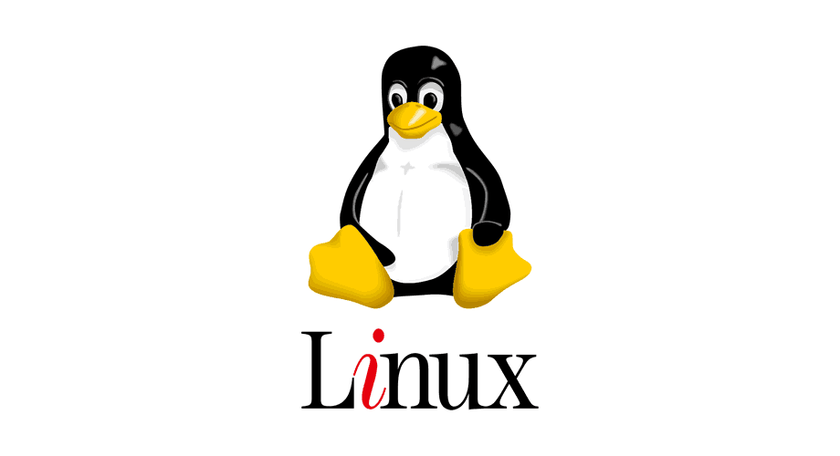

* **LINUX Operating System:**

The Linux OS is an open-source operating system project that is a freely distributed, cross-platform operating system developed based on UNIX. It is basically the system software on a computer that allows apps and users to perform some specific task on the computer.

**Features**:

Linux is free can be downloaded from the Internet or redistribute it under GNU licenses and has the best community support.

Linux OS is easily portable which means it can be installed on various types of devices like mobile, tablet computers.

It is a multi-user, multitasking operating system.

BASH is the Linux interpreter program which can be used to execute commands.



* **Android Mobile Operating System:**

Android is a Google’s Linux based operating system it is designed primarily for touch screen mobile devices such as smart phones and tablet computers. The hardware which can be used to support android is based on three architectures namely ARM, Intel and MIPS design.

**Features**:

The android operating system is an open source operating system means that it’s free and any one can use it.

Android offers optimized 2D and 3D graphics, multimedia, GSM connectivity, multi-tasking.

Android OS is known for its friendly user interface and exceptional customizable according to the user’s taste.



* **iOS Mobile Operating System:**

iOS which is short for iPhone OS is a mobile operating system created and developed by Apple Inc. exclusively for its hardware like A12 Bionic chip that presently powers many of its mobile devices, including the iPhone, iPad, and iPod.

**Features**:

It is written in C, C++, Objective-C and Swift and is based on the Macintosh OS X.

Has excellent and intuitive user interface and very fluid response.

Performance of iOS is unbeatable.

# Unix OS

Unix is an Operating System that is truly the base of all Operating Systems like Ubuntu, Solaris, POSIX, etc. It was developed in the 1970s by Ken Thompson, Dennis Ritchie, and others in the AT&T Laboratories. It was originally meant for programmers developing software rather than non-programmers.

## Some of the key features of UNIX include:

1. Multiuser support: UNIX allows multiple users to simultaneously access the same system and share resources.
2. Multitasking: UNIX is capable of running multiple processes at the same time.
3. Shell scripting: UNIX provides a powerful scripting language that allows users to automate tasks.
4. Security: UNIX has a robust security model that includes file permissions, user accounts, and network security features.
5. Portability: UNIX can run on a wide variety of hardware platforms, from small embedded systems to large mainframe computers.

## Unix OS Distribution

1. **Ubuntu**: Known for its user-friendliness and strong community support, Ubuntu is a great choice for beginners.
2. **Fedora**: A cutting-edge distribution sponsored by Red Hat, often used by developers and enthusiasts.
3. **Kali Linux**: Designed for cybersecurity professionals and ethical hackers, it comes with a wide range of security tools pre-installed.
4. **macOS**: macOS, developed by Apple Inc., is built on a Unix-based foundation called Darwin. It features a user-friendly graphical interface and is known for its integration with Apple hardware and software.
5. **FreeBSD**: FreeBSD is a Unix-like operating system known for its focus on performance and advanced networking capabilities. It's often used in server environments.
6. **OpenBSD**: OpenBSD is a Unix-like operating system with a strong emphasis on security and correctness. It's used in security-critical applications.
7. **Solaris**: Solaris, developed by Sun Microsystems (now part of Oracle), is a commercial Unix-based operating system known for its scalability and features like ZFS and DTrace.

## History Of Unix

UNIX development was started in 1969 at Bell Laboratories in New Jersey. Bell Laboratories was (1964–1968) involved on the development of a multi-user, time-sharing operating system called Multics (Multiplexed Information and Computing System). Multics was a failure.

In early 1969, Bell Labs withdrew from the Multics project. Bell Labs researchers, including Ken Thompson, Dennis Ritchie, Douglas McIlroy, Joseph Ossanna, and others, aimed to create a new operating system for both their programming and Bell Labs' needs, such as job control and resource usage. This effort led to the creation of UNICS (UNiplexed Information and Computing Service), essentially a stripped-down version of Multics.

Unix V6, released in 1975 became very popular. Unix V6 was free and was distributed with its source code.

In 1983, AT&T released Unix System V which was a commercial version.

Meanwhile, the University of California at Berkeley started the development of its own version of Unix. Berkeley was also involved in the inclusion of Transmission Control Protocol/Internet Protocol (TCP/IP) networking protocol.

## Application of Linux

1. Server Administration: Unix is the foundation for many server operating systems, such as Linux distributions, FreeBSD, and Solaris. It's widely used for web servers (e.g., Apache), database servers (e.g., MySQL, PostgreSQL), and cloud infrastructure management.
2. Development and Programming: Unix is a favorite among developers and programmers. It provides powerful command-line tools, development environments (e.g., GCC), and scripting languages (e.g., Bash, Python) for software development.
3. Networking: Unix-based systems offer robust networking capabilities, making them ideal for routers, firewalls, and networking equipment. The TCP/IP stack, essential for internet communication, was developed on Unix.
4. System Administration: Unix's multi-user, multi-tasking capabilities make it well-suited for system administrators managing large networks, user accounts, and security configurations.
5. Web Development and Hosting: Unix-based servers, especially Linux, dominate web hosting. Popular content management systems (e.g., WordPress) and web frameworks (e.g., Ruby on Rails) run on Unix.
6. Embedded Systems: Unix-like systems can be scaled down and adapted for use in embedded systems, such as routers, IoT devices, and industrial automation.
7. Education: Unix is often used in computer science and IT education to teach fundamental concepts like file systems, process management, and network protocols.
8. Creative Arts: Unix-based systems like macOS are popular among creative professionals for tasks such as graphic design, video editing, and music production.

## Comparison of Unix and Windows

1. **History and Development:**

- Unix: Unix is a family of operating systems that originated in the late 1960s. It has various flavors, including AIX, HP-UX, Solaris, and Linux (a Unix-like OS).

- Windows: Windows, developed by Microsoft, was first released in the mid-1980s. It has evolved through numerous versions, with Windows NT forming the basis for modern Windows versions.

2. **User Interface**:

- Unix: Unix traditionally uses a command-line interface (CLI), but many Unix-like systems offer graphical user interfaces (GUIs) as well.

- Windows: Windows is known for its graphical user interface, making it more user-friendly for beginners.

3. **File System**:

- Unix: Typically uses a hierarchical file system with a single root directory (represented by "/"). It has case-sensitive file names.

- Windows: Uses a drive-letter-based file system (e.g., C:\) and is case-insensitive by default (though it can be configured to be case-sensitive).

4. **Security**:

- Unix: Unix-based systems are known for their robust security features and fine-grained permission control. They often follow the principle of least privilege.

- Windows: Windows has improved its security over the years but has been historically more susceptible to malware and security vulnerabilities. However, recent Windows versions have made significant strides in security.

5. **Software Availability**:

- Unix: Unix systems have a rich ecosystem of open-source software available through package managers like apt, yum, and ports. Commercial software is also available.

- Windows: Windows has a vast selection of commercial software, including many proprietary applications. It also supports open-source software, but the availability may be somewhat limited compared to Unix.

6. **Compatibility**:

- Unix: Unix systems are known for their compatibility with programming languages, development tools, and networking protocols. They are often preferred for server and scientific computing environments.

- Windows: Windows is widely used in desktop computing and is compatible with many commercial applications and games. It may require additional software or configuration for compatibility with some development environments.

7. **Customization**:

- Unix: Unix systems are highly customizable and can be tailored to specific needs through scripting, configuration files, and package installations.

- Windows: While Windows offers some degree of customization, it is generally considered less flexible in this regard compared to Unix.

8. **Licensing**:

- Unix: Many Unix-based operating systems, including Linux, are open source and have permissive licenses. Some Unix variants, like AIX and Solaris, are proprietary.

- Windows: Windows is a proprietary operating system, and users typically need to purchase licenses for its various editions.